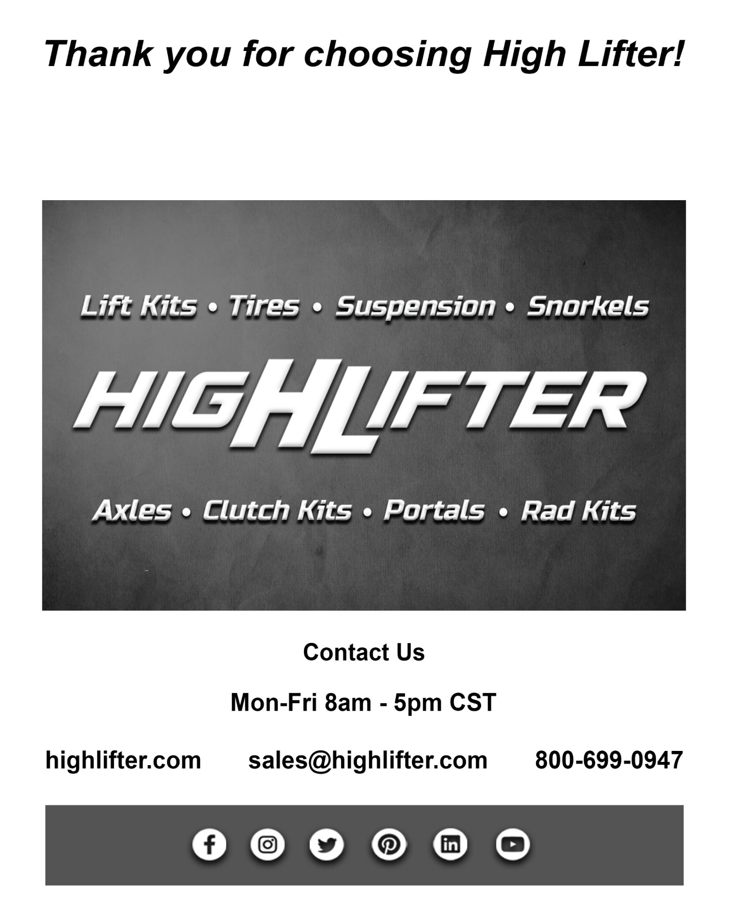
HLK700P-52

2.5" Signature Series Lift Kit Honda Pioneer 700

Installation Instructions 1


Shreveport, LA (318)-524-2270

Read before Installation

This product is designed for use on ATVs and/or RUVs to increase ground clearance and fender clearance. Purchasers should be aware that use of this product may increase the frequency of required maintenance, part wear, and will raise the center of gravity on your ATV and/or RUV, increasing risk of roll-over, injury and death on all types of terrain. It is your responsibility to always inform other operators and passengers of this vehicle about the added risks.

High Lifter Products, products are designed to best fit users ATV/RUV under stock conditions. Adding, modifying, or fabricating any OEM or aftermarket parts will void warranty. High Lifter Products, products could interfere with other aftermarket accessories. If the user has aftermarket products on machine, contact High Lifter Products to verify that they will work together. Adding aftermarket suspension components and/or more aggressive tires can cause breakage of other OEM driveline components such as differentials, axles or drive shafts.

We recommend that wider tires and/or wheel spacers be used to achieve a wider stance and to improve stability of the ATV and/or RUV. Riders should be advised that the handling characteristics of a taller ATV and/or RUV are different and require extra care when riding, particularly on side hills or off-camber situations. If you further raise the center of gravity by adding taller tires, heavy loads to racks or seats, or by any other means, the ATV and/or RUV must be operated with even more care, at slower speeds and on relatively flat ground. All turns should be done at a slow speed, even on level ground.

Operation of an ATV and/or RUV with or without modified suspension components, while or shortly after consuming alcohol or drugs, subjects the rider to the risk of serious bodily harm or possible death. This risk is compounded if the rider does not wear an approved helmet and other safety gear. High Lifter urges that all approved safety gear be worn when riding an ATV and/or RUV as a driver or passenger.

By purchasing and installing High Lifter Products, products, user agrees that should damages occur, High Lifter Products will not be held responsible for loss of time, use, labor fees, replacement parts, or freight charges. High Lifter Products will not be held responsible for any direct, indirect, incidental, special, or consequential damages that result from any product purchased from High Lifter Products. The total liability of seller to user for all damages, losses, and causes of action, shall not exceed the total purchase price paid for the product that gives rise to the claim.

Dealers and other Installers

You are responsible for informing your customer and end user of the information contained above and the increased potential hazards of operating an ATV and/or RUV equipped with modified suspension components. If you install any suspension modifying components, it is your responsibility to also install the warning label prominently in view of the driver and in prominent view of the driver and passenger on RUVs and multi-passenger ATVs. They should also be instructed to notify anyone operating the vehicle, as well as any passengers, that said vehicle is modified.

As discussed above, it is critically important that they be instructed in the need for slower speed operation, regardless of terrain, after this lift kit is installed.

Parts Diagram
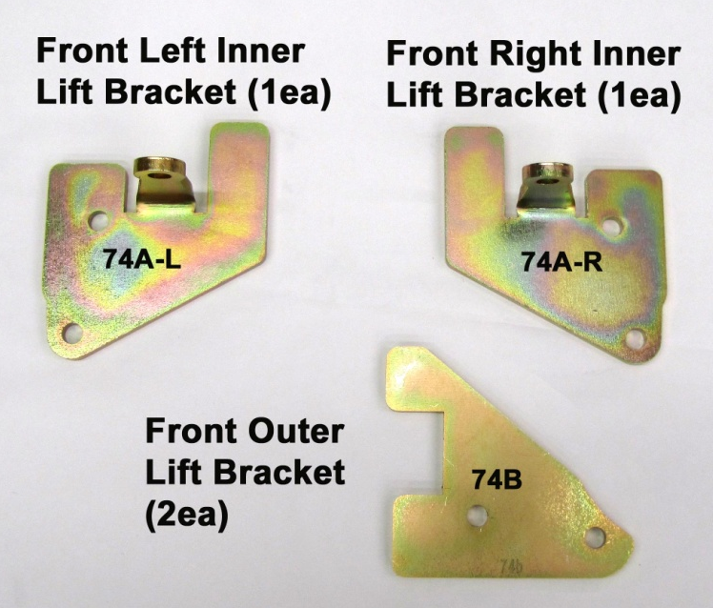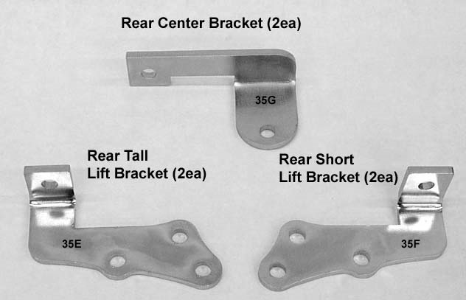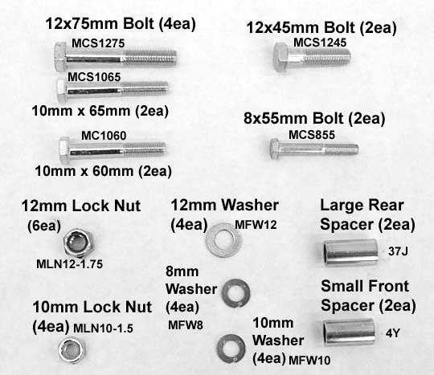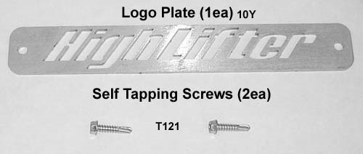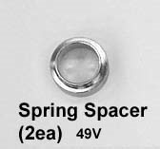
Front Lift Installation NOTE: On 2017 models you will need to trim the light housing on the front of the UTV.
- Place jack under center of UTV front end and lift until front wheels clear the ground. Be careful to support UTV properly so that it is securely supported but so that A-arms and shocks can droop to full extension.
- Remove front wheels.
- Remove the bolt that connects the support bracket from the frame on both sides of the UTV at this time.
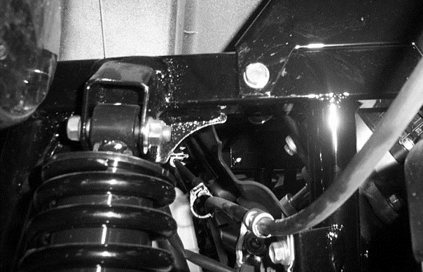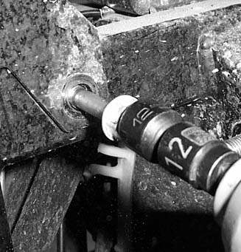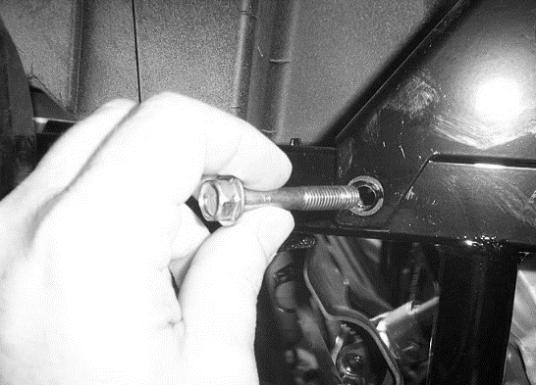

- Next disconnect the shock from the shock mounts.
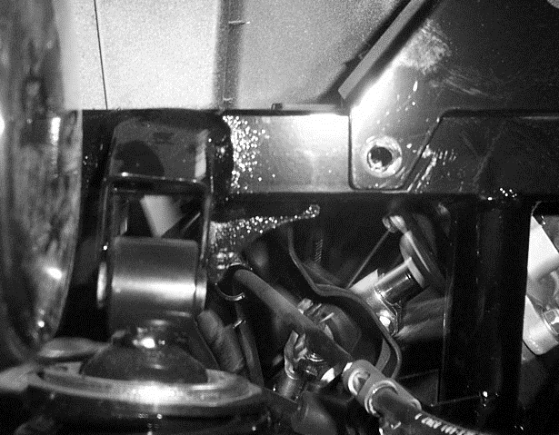

- You have an option at this point to install the spring stiffeners or leave them out of the kit. The spring stiffeners will preload the shock springs and give you an extra 1” of lift. You must have an automotive grade spring compressor to install the spring stiffeners. Here are the steps for installation.

- Remove the shocks from the UTV.
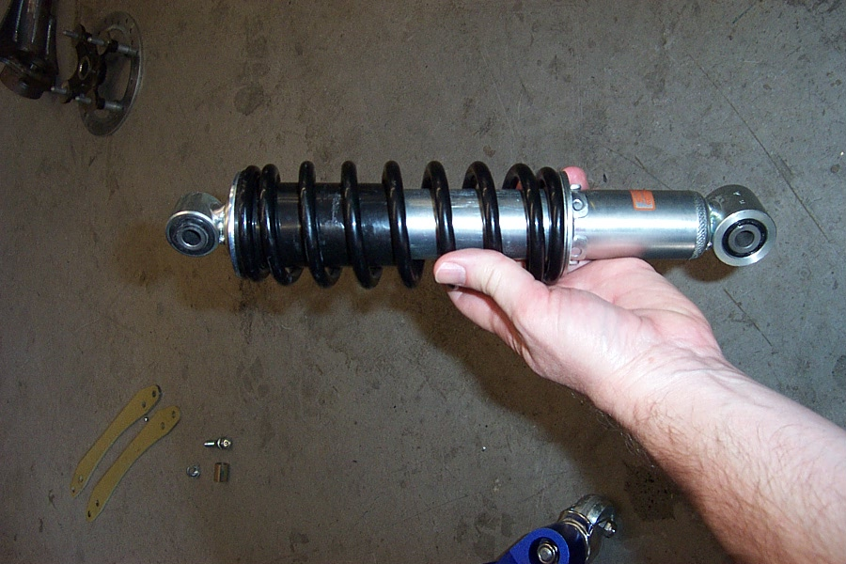
- Using a spring compressor, compress the factory spring. Remove the retaining clip that secure the spring in place.
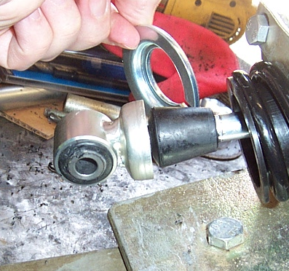

- Now remove the factory spring.
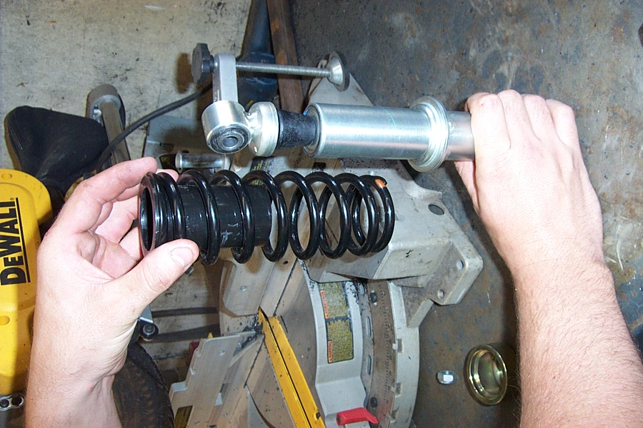

- Slide the stiffener onto the shock.
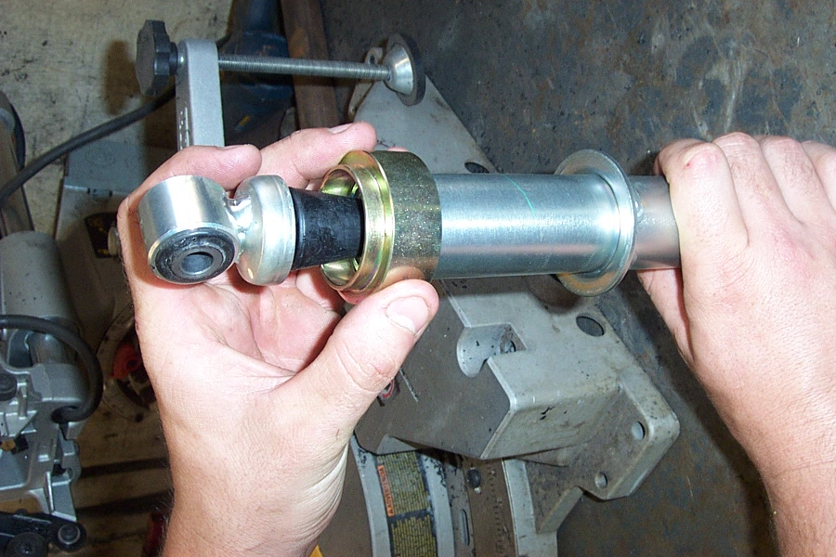
- Place the spring back on the shock and secure it in place with the retaining clip.
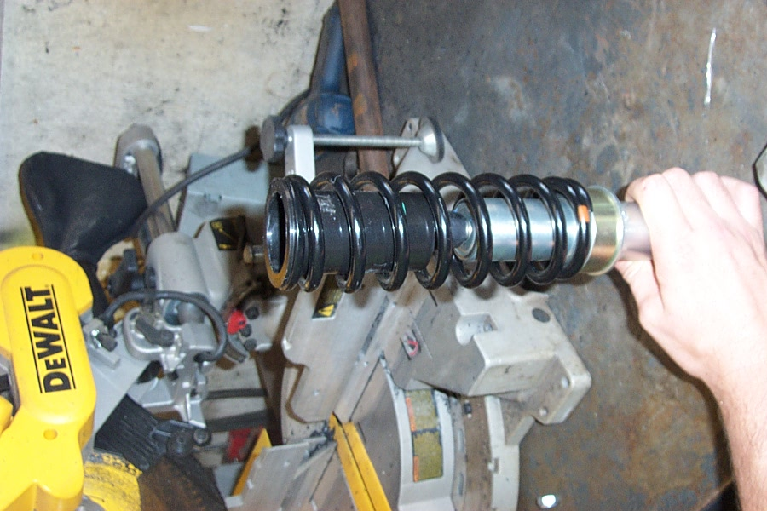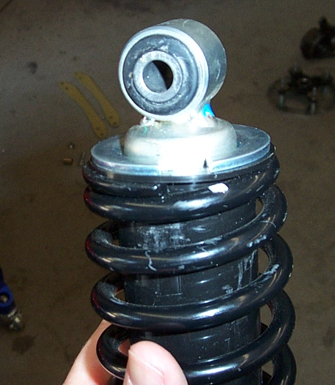

- Place the Front Lift bracket to the rear facing side of the shock mount tab.
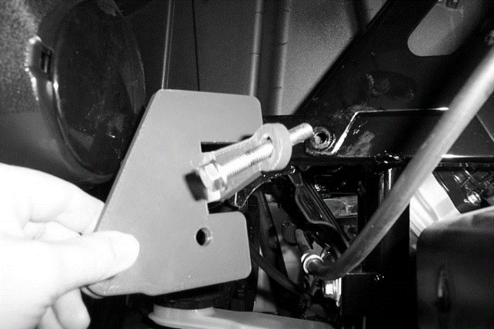

- Align the tab on the bracket with the bolt hole that connects the support bracket to the frame. Secure the tab to the frame using the 8x55mm bolt and 8mm washer provided in the kit.
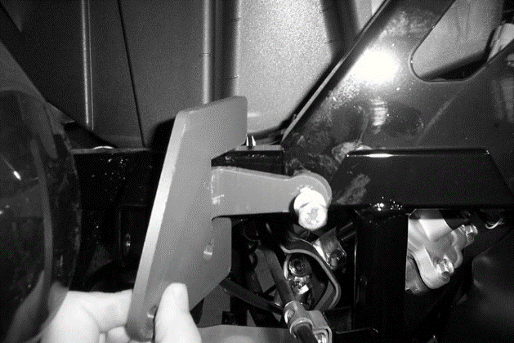

- Insert the 10x65mm bolt through the bracket and place a Small Spacer between the shock mount tabs. Continue to push the bolt all the way through the spacer until it comes out the other side of the shock mount tab.
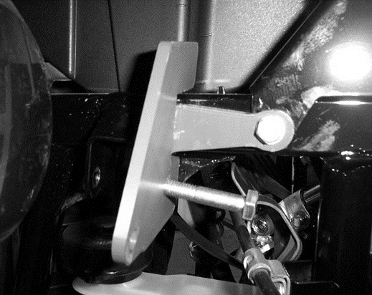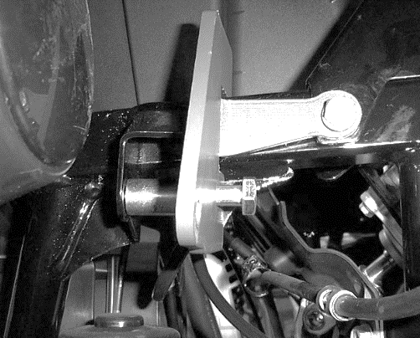
- Next insert the front lift bracket to the outside of the shock mount tab onto the bolt that was just inserted through the factory shock mount location. Fasten the bracket to the bolt using the 10mm lock nut provided.
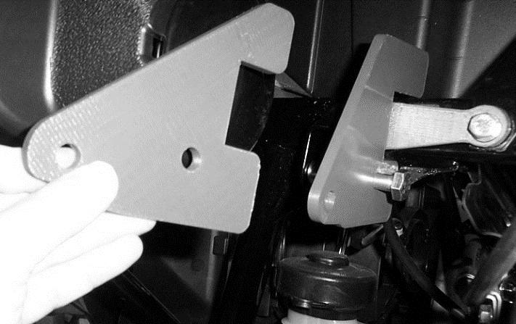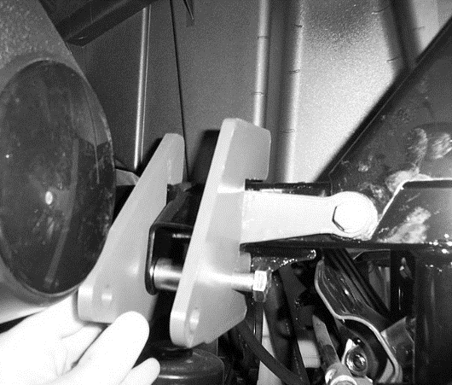

- Connect the shock between the two lift brackets.

- Next insert the 10x60mm bolt through the bracket, but before you push it through the shock eyelet place 10mm washers on either side of the shock eye.
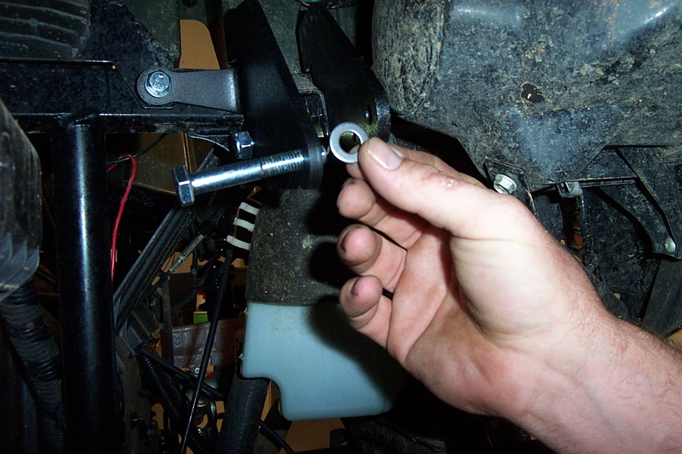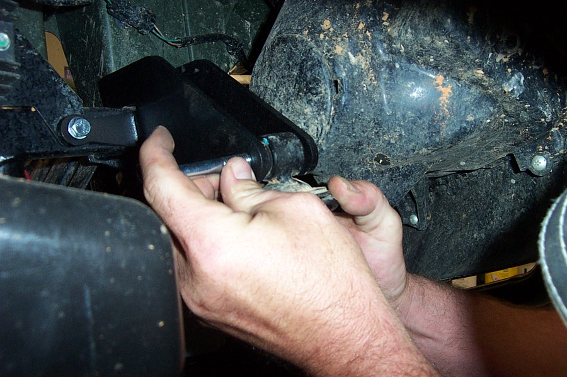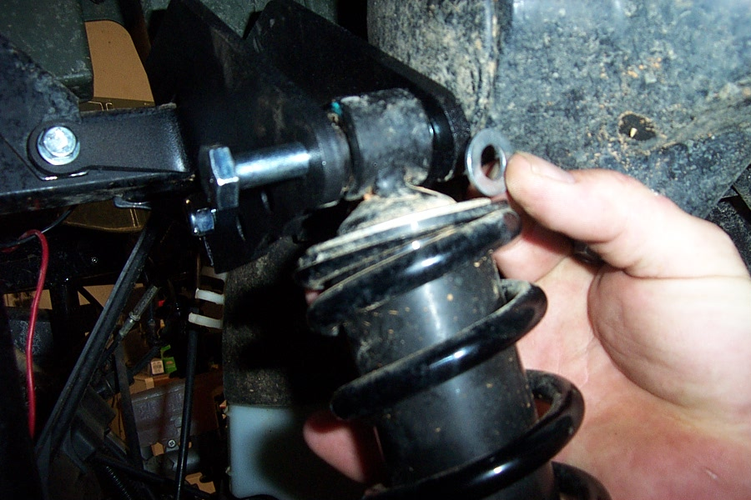

- Push the bolt through the washers and shock eye, then through the bracket. Once it is through secure it with the 10mm lock nut provided.
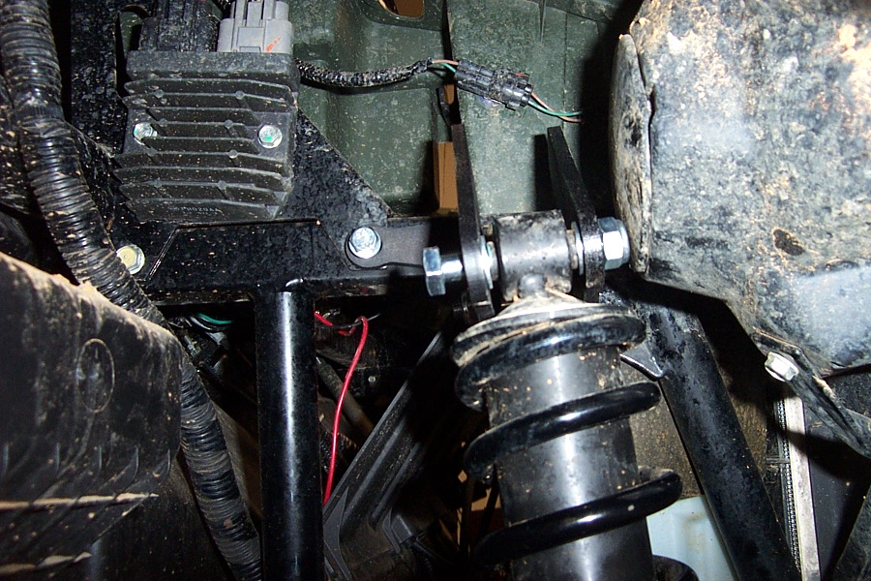

- Make sure all bolts are tightened to manufacturer’s torque specification and repeat steps for opposite side.

- Install the wheels, torque wheel lug nuts to manufacturer’s specifications, lower and remove jack. Always check for clearance problems or misalignment!

Rear Lift Installation
- Place jack under center of UTV rear end and lift until rear wheels clear the ground. Be careful to support UTV properly so that it is securely supported but so that A-arms and shocks can droop to full extension. Lift the dump bed for this installation!

- Before you start the installation process for the rear lift you will need to loosen the lock nuts that secure the upper and lower rear control arms at the frame and hub assembly. Just loosen them, do not remove them. This will allow them to further drop to full extension.
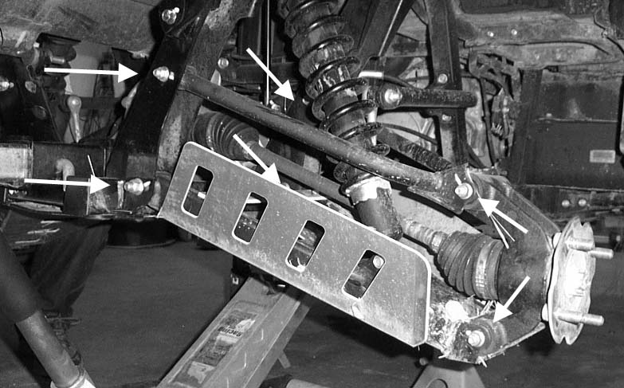

- Now disconnect the top of the shock from the shock mount tabs on the frame.

- Next you need to know that you will be stacking the brackets then securing them all together with one bolt. The order of the brackets will be important. Always make sure that the taller bracket is on the bottom, the shorter bracket is in the middle and the center bracket is on top. Depending on which side you are working on the position of the bracket may be different on the frame, but the order of the stack will never change.
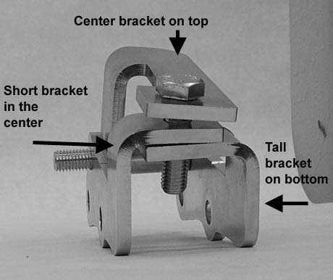

- To determine which bracket is tall and which is short place the bracket on their side and see the height of the leg.
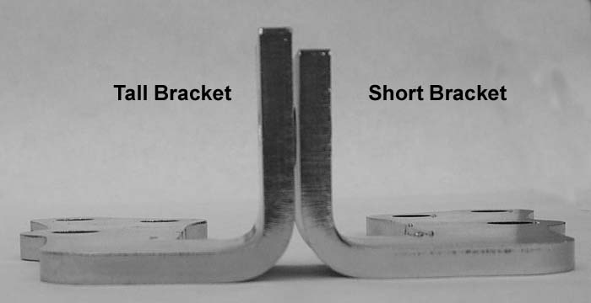

- The position illustrated in the next few sets will be from the rear left. Left and right are determined from the driver’s seat position.

- Insert the support bracket into the frame gusset that runs between the center of the rear portion of the frame. Insert it so that the rounded tab portion of the bracket inserts into the frame gusset and the flat portion rest on the frame.
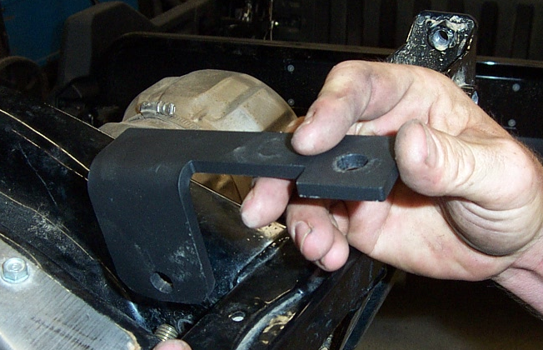

- Install the brackets outside but next to the shock mount and loosely fasten those brackets and the center bracket. Make sure that they are placed such that the center bracket is on top, then the short bracket and finally the tall bracket. You must also insert the Large Spacer between the shock mount tab and center bracket.

- Using a 12x75mm bolt and 12mm lock nut connect the brackets and spacer to the UTV.

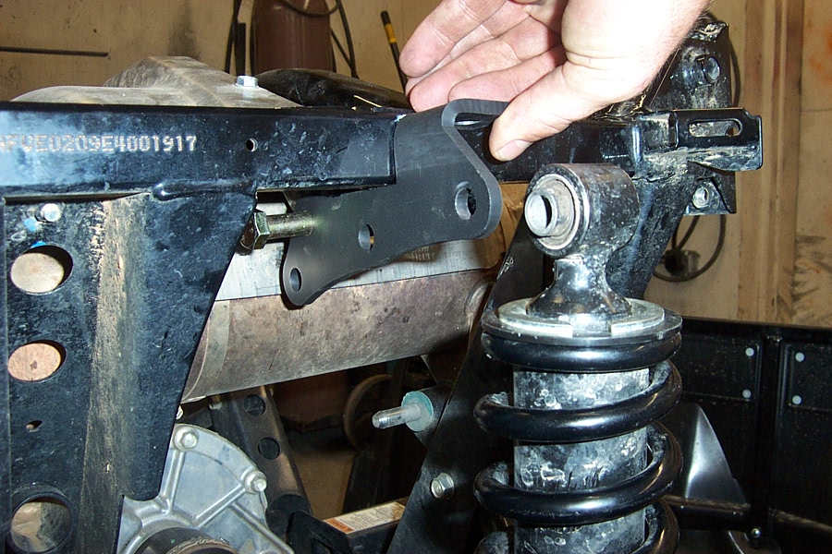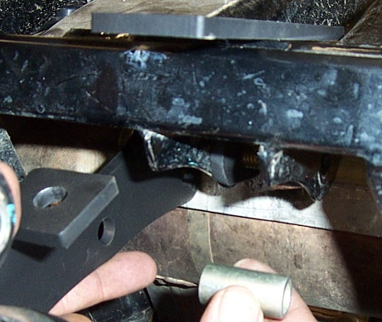

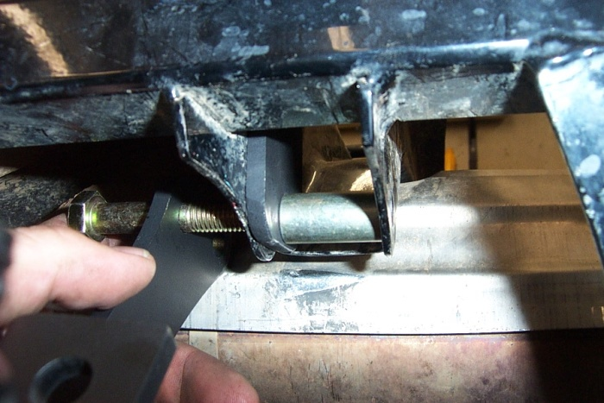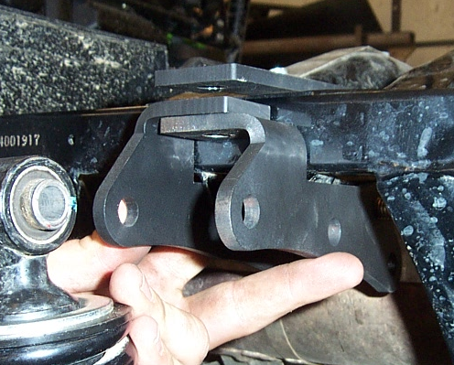

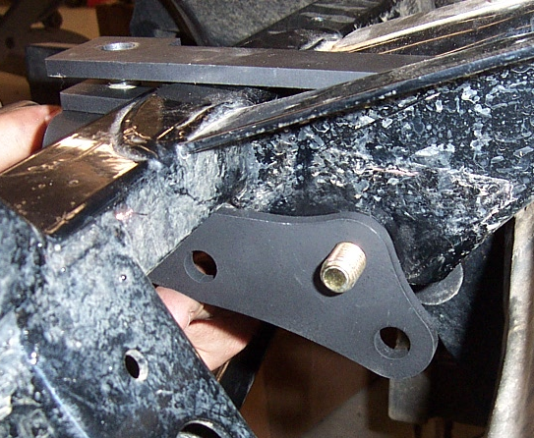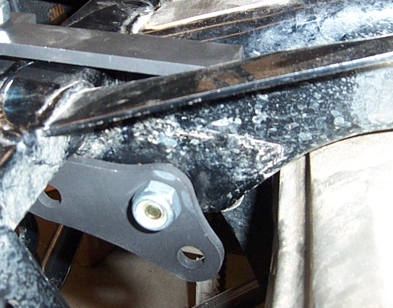

- Insert the 12x45mm bolt through the brackets and fasten with a 12mm lock nut.
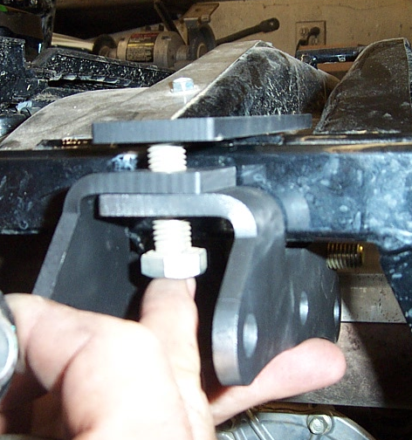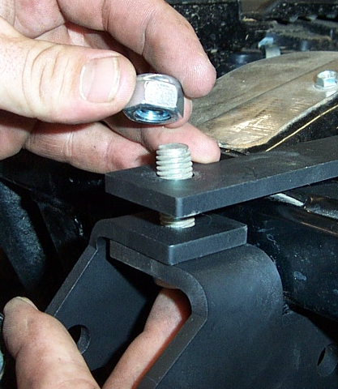

- Connect the shock to the hole to the outside of the brackets. This will give you the maximum lift. If you feel the ride is to stiff you can move the shock to the hole closest to the frame.
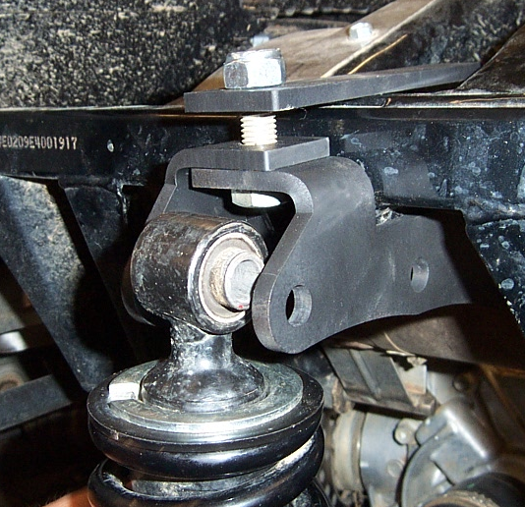

- Connect the shock using a 12x75mm bolt, two 12mm washers, and 12mm lock nut. Place the 12mm washers on either side of the shock eyelet.
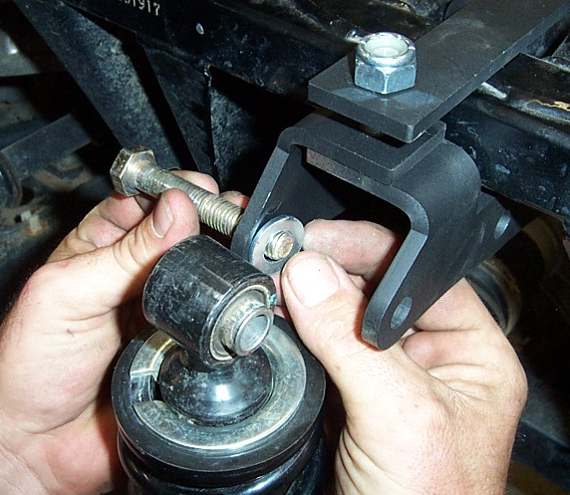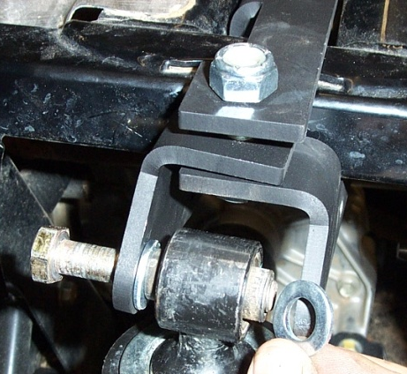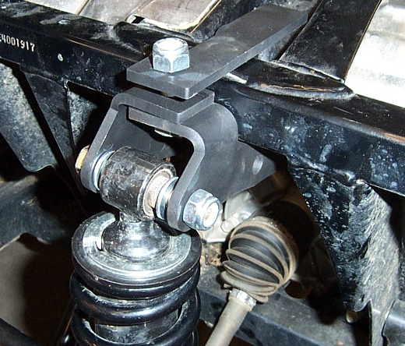

- Repeat steps for the opposite side.
- Make sure to re-torque all of the control arm lock nuts to the factory specifications.
- Install the wheels, torque wheel lug nuts to manufacturer’s specifications, lower and remove jack.
- Always check for clearance problems or misalignment.

Logo Plate Installation
- On the tailgate of the bed you will need to center the logo plate.
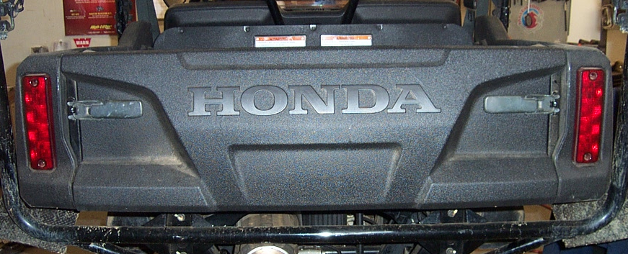

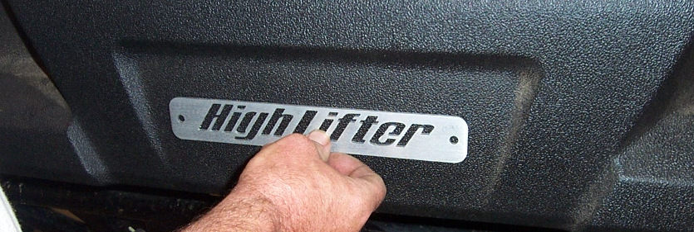
- Using the self tapping screws provided in the kit, connect the logo plate to the tailgate.
